\*\*\*\*\*\*\*\*\*\*\*\*\*\*\*\*\*\*\*\*\*\*\*\*\*\*\*\*\*\*\*\*\***True NAS Installation**\*\*\*\*\*\*\*\*\*\*\*\*\*\*\*\*\*\*\*\*\*\*\*\*\*\*\*\*\*\*\*\*

Prerequisite:

1)True NAS VM

Configuration:-

RAM-4GB

CPU-4

Storage :- 5 Disk Per Disk 20 GB

**Step1: Click on File tab and Select New Virtual Machine**

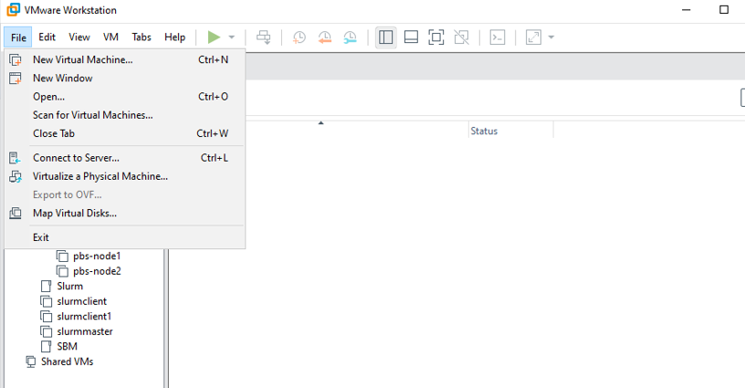

**Step2: Next**

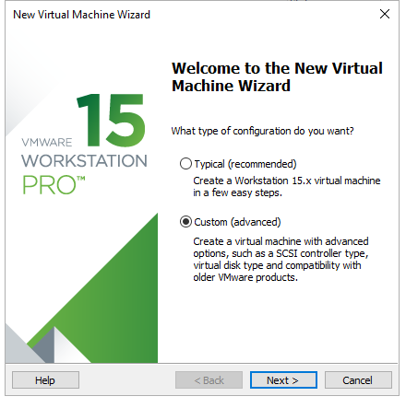

**Step3:Again Next**

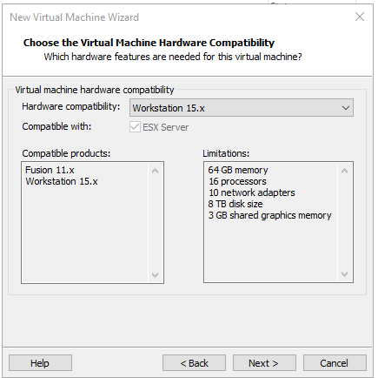

**Step4: Browse and selct True Nas ISO**

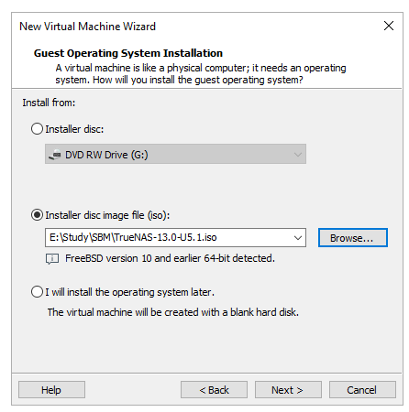

**Step5: Give to True NAS name to Virtual Machine and NEXT.**

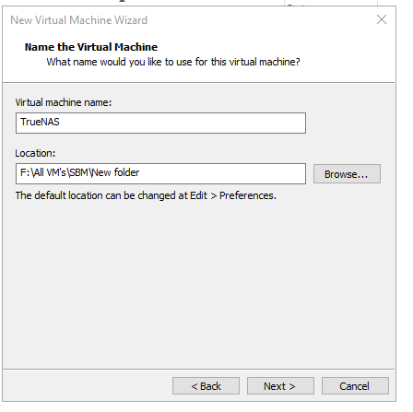

**Step6: Give to 2 Number of processors and 2 core per processor.**

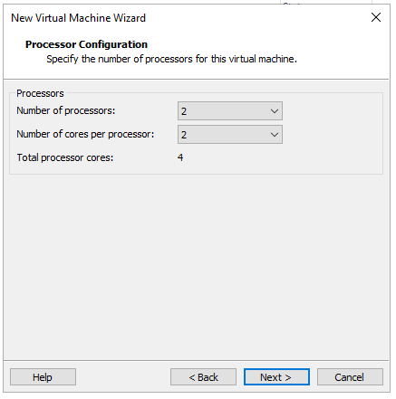

**Step7: Select 8 GB RAM and Next.**

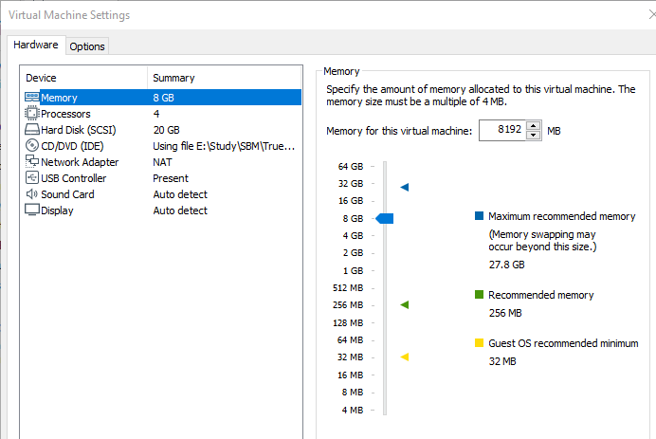

**Step8: Use Network Type NAT and NEXT.**

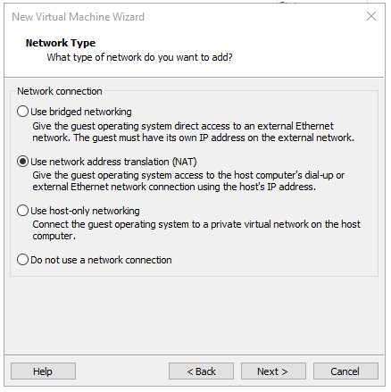

**Step9: Select Recommended I/O controller and NEXT.**

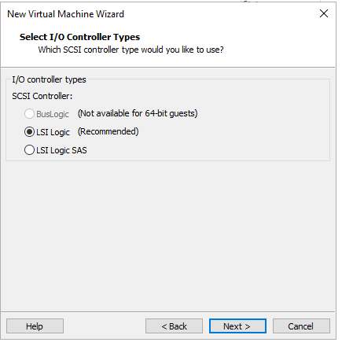

**Step10: Select a Disk type SCSI as per Recommended and NEXT.**



**Step11: Create a new Virtual Disk and NEXT.**

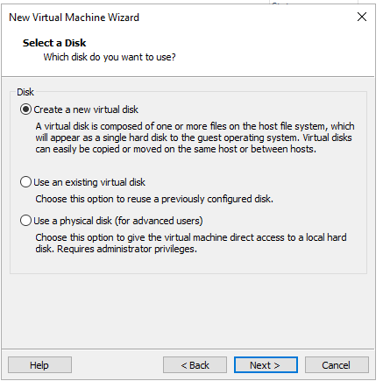

**Step12: Specify Disk Capacity 20 GB and checked on Store virtual disk as a single file.**

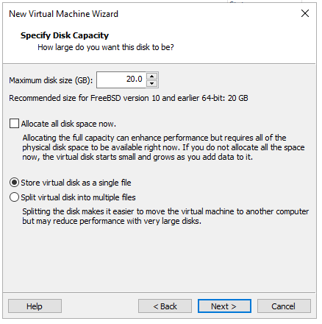

**Step13: Browse VMDK save file Location Path.**

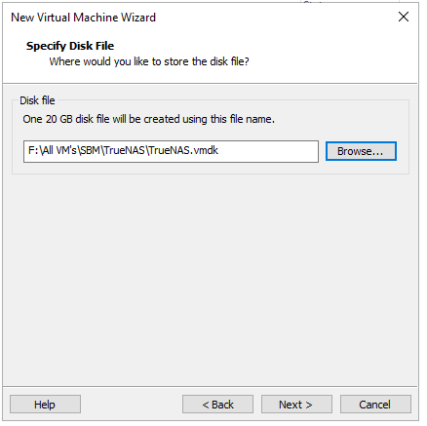

**Step14: Click on Finish.**

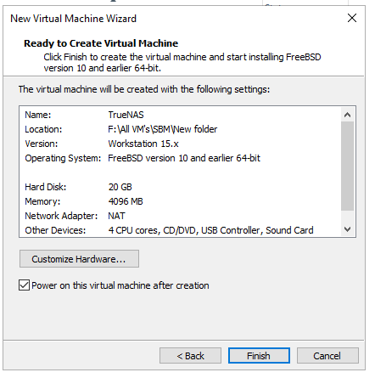

**Step15: Then Shutdown machine and add more 5 Disk.**

-Click on the Edit Virtual Machine settings.

- Then click on Add Button

-Select Hard Disk and NEXT.

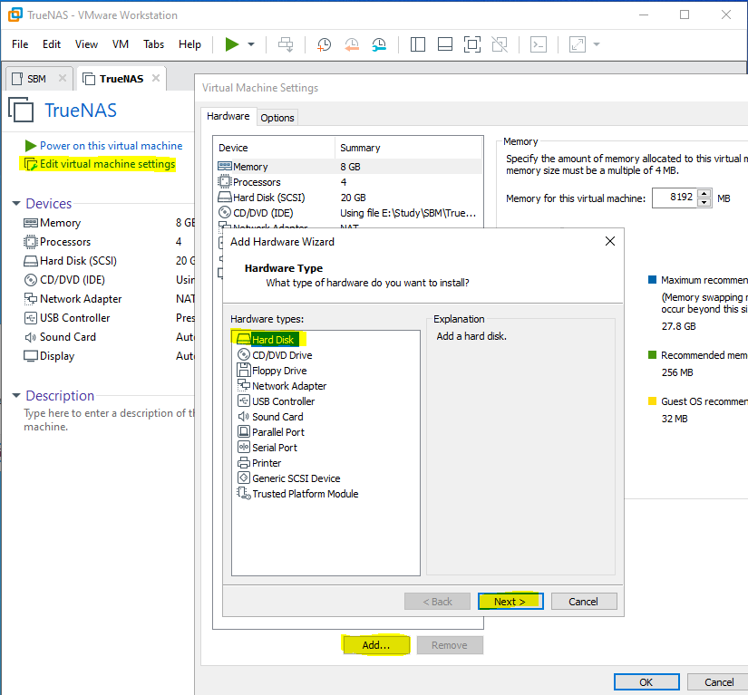

-Then select SCSI recommended and next.

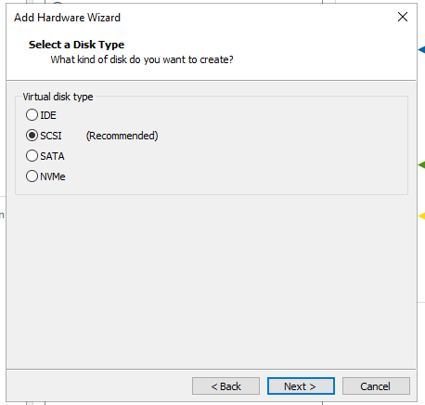

-Next

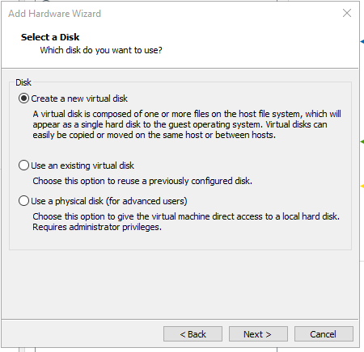

* Disk capacity 20 GB checked Store virtual disk and Next.

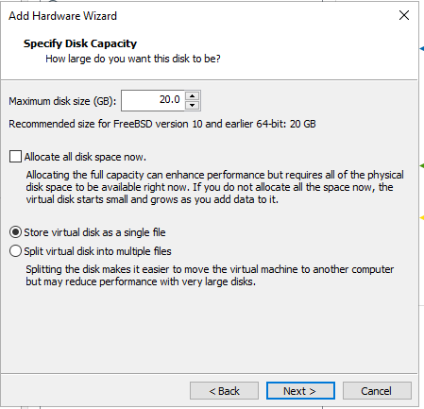

* Browse path and and Finish.

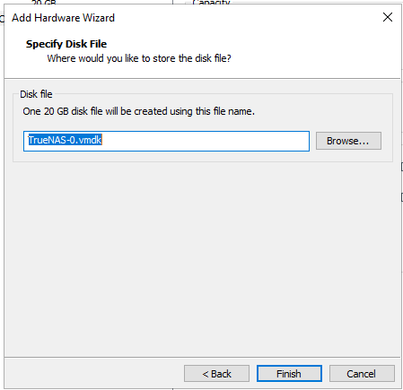

Do the same process for adding next Hard drive and ok.

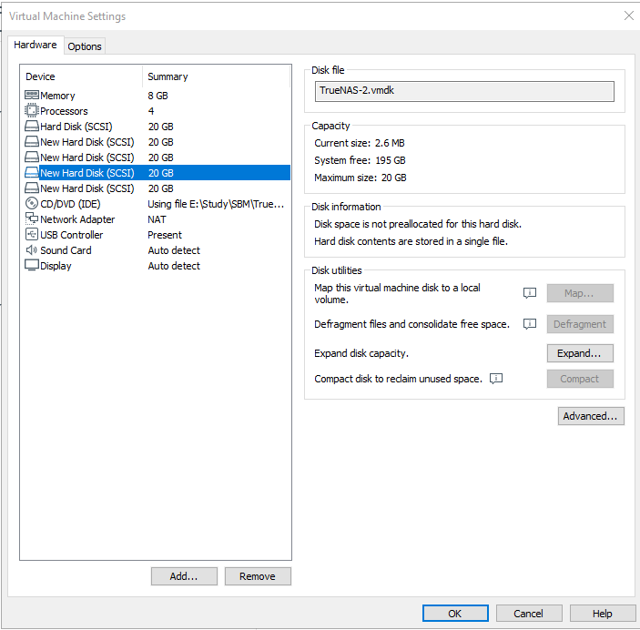

**Step1: Then next window will show automatically.**

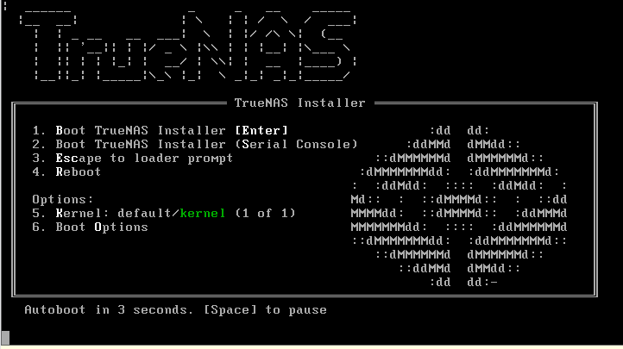

**Step16: Then Ok On Install/ Upgrade.**

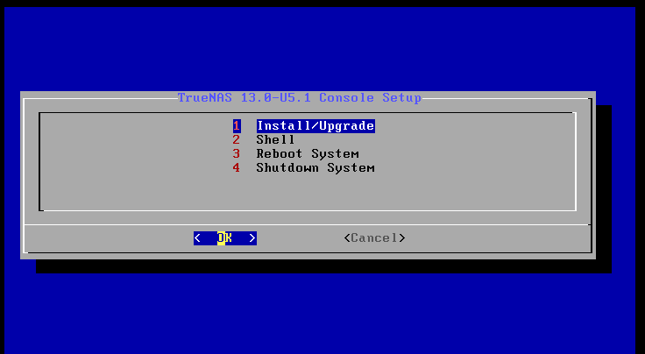

**Step17: da0 and OK**

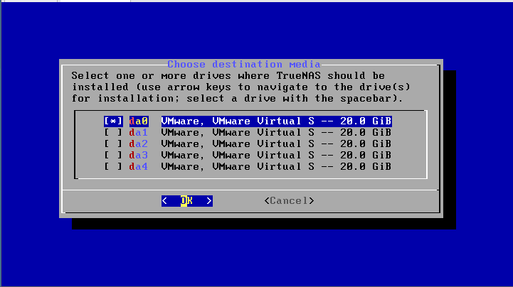

**Step18: Click on Yes.**

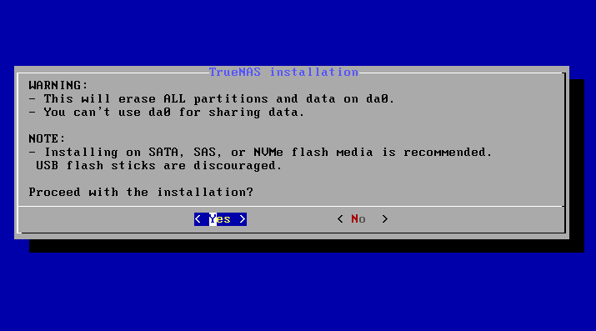

**Step19: Put root user password.**

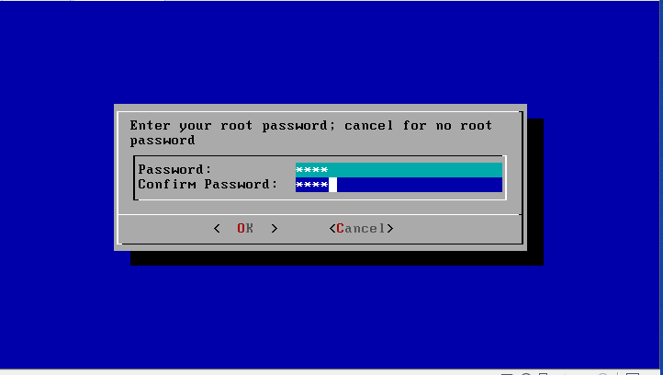

**Step20: Select On via BIOS.**

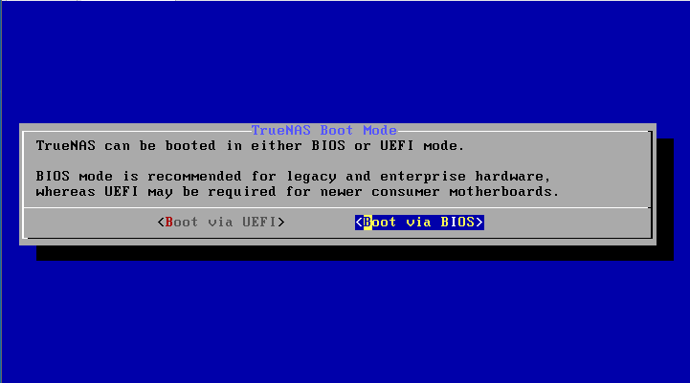

**Step21: Installation process**

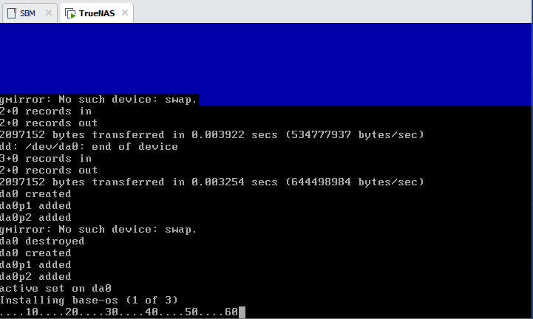

**Step22: Click On Ok**

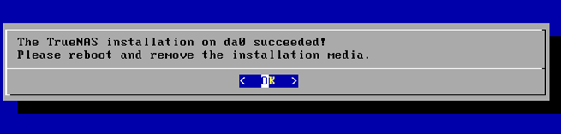

**Step23: Select on Reboot System. And Ok.**

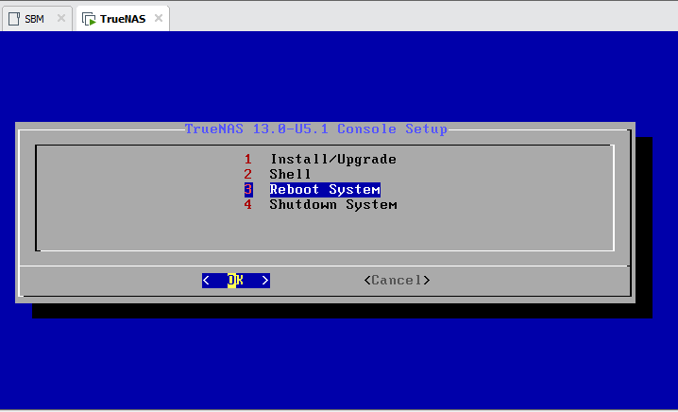

**Step24: Take IP address and put on Browser.**

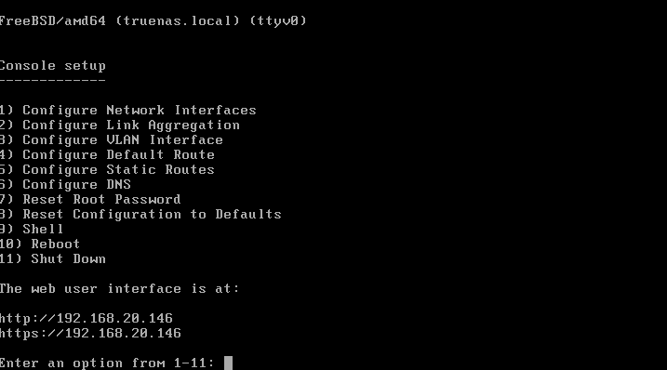

**Step25: Open Browser put IP address put username root and password.**

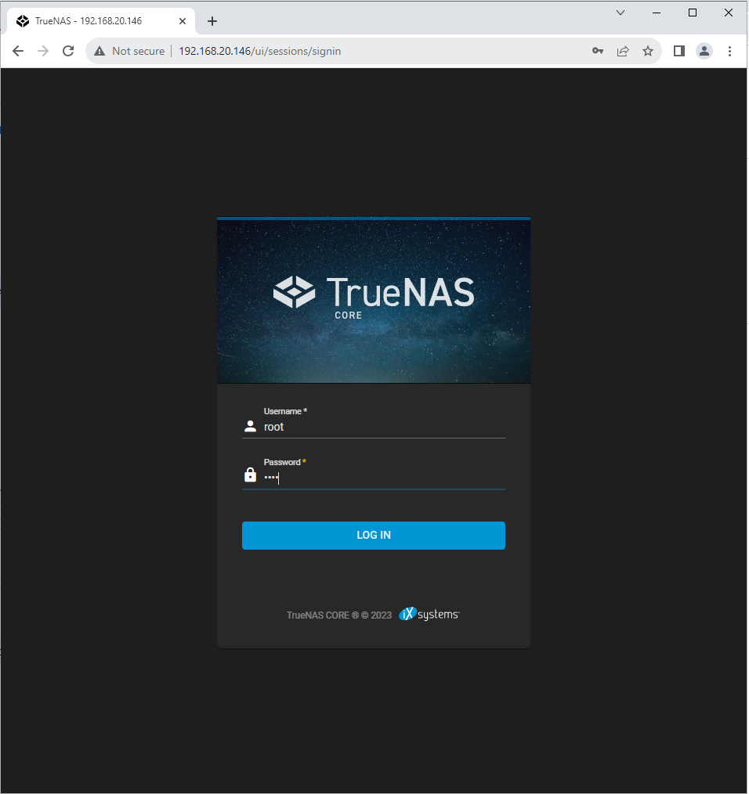

**Step26: See True NAS Dashboard.**

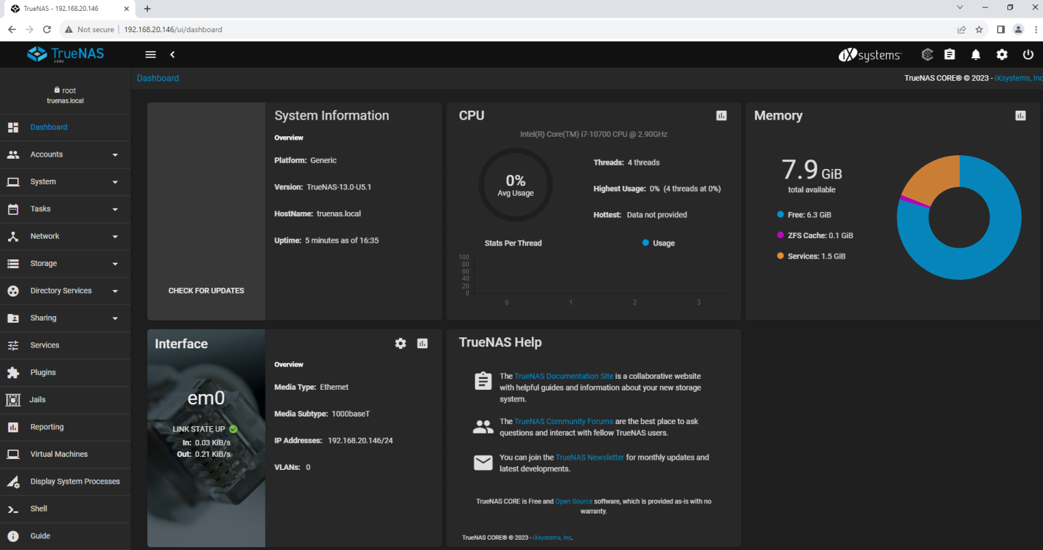

**Step27: Click on Storage**

-then Pools

- Add pool and click on Create new pool and Create pool.

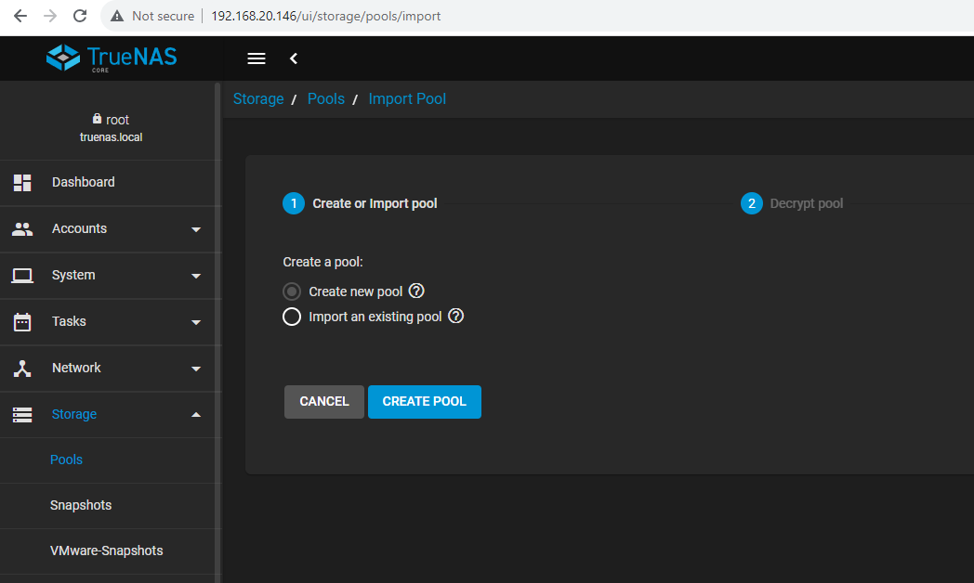

**Step28: Give pool name and Select all disk and transfer on other side and click on create pool.**

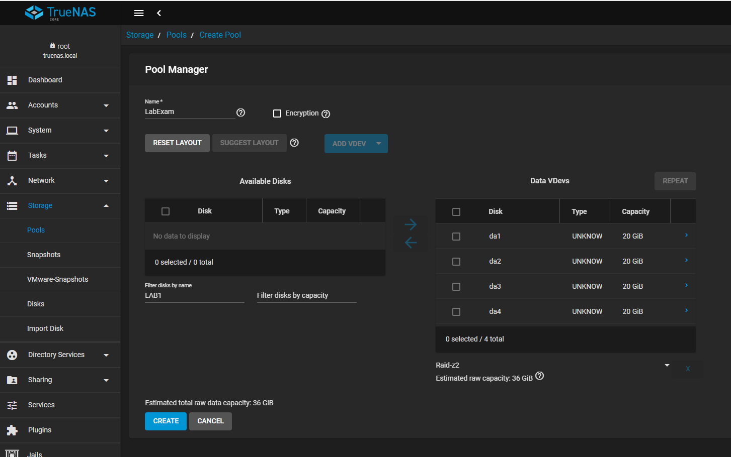

**Step29: Click on Confirm and create pool.**

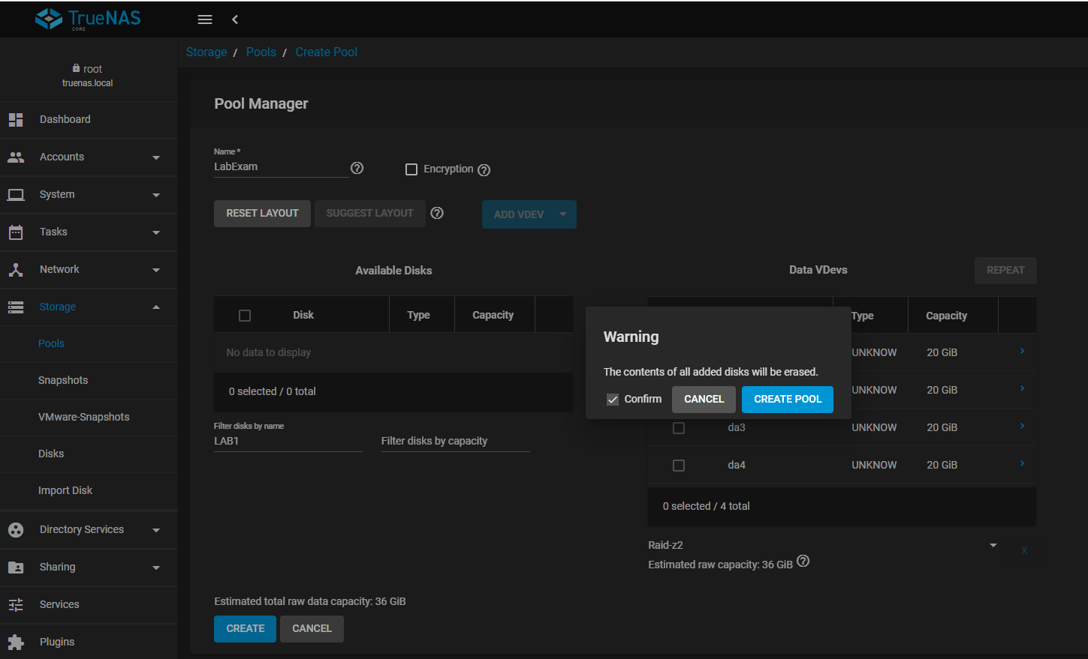

Step30: Then See Pool is created.

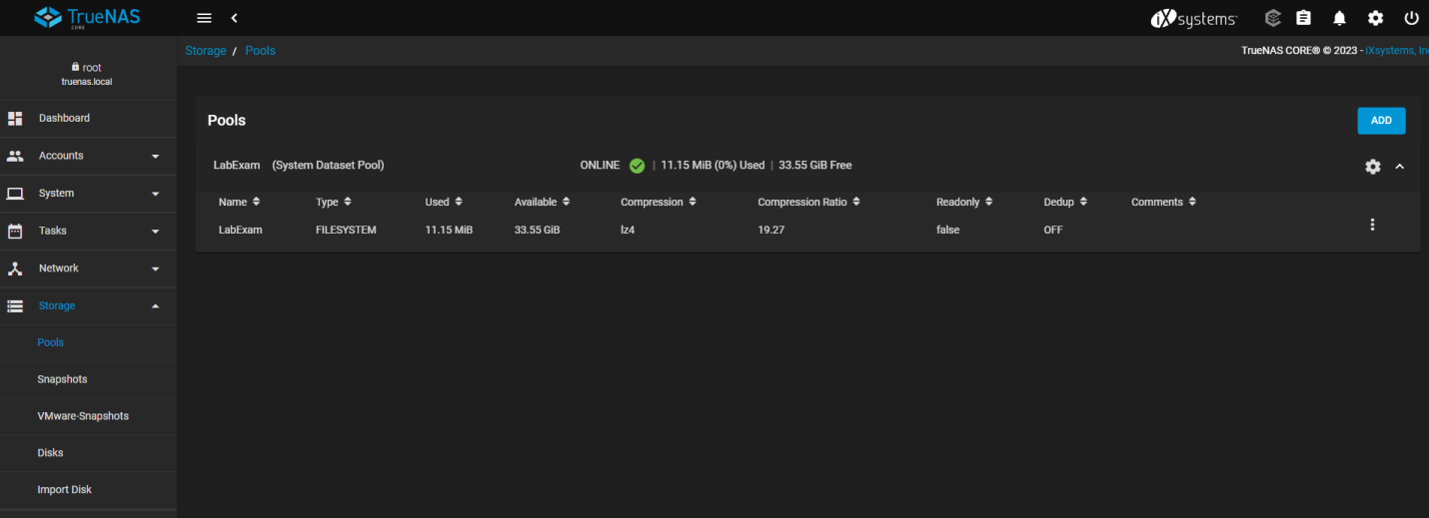

Step31: Then give name and save.

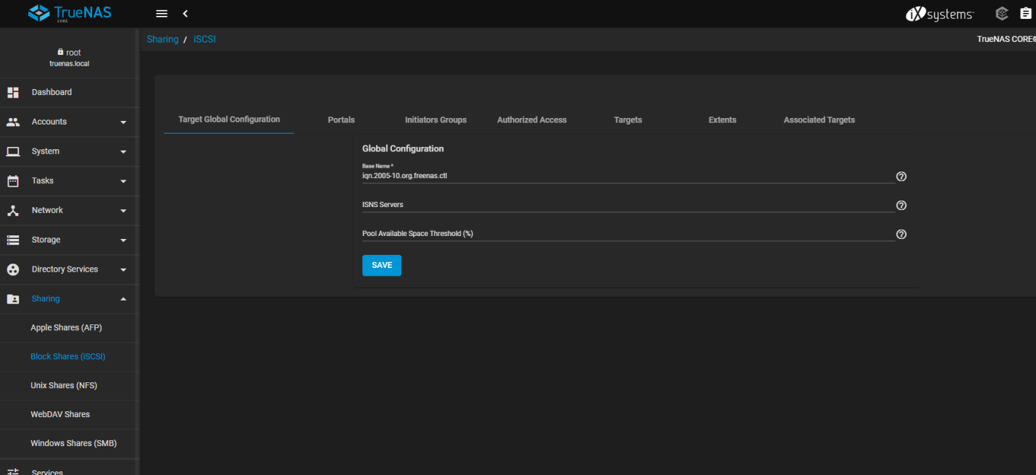

Step32: Click on Enable Service.

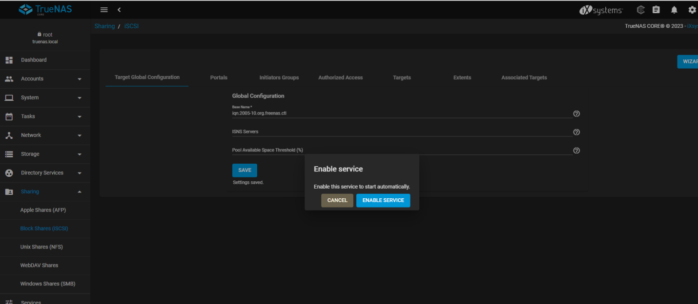

Step33: Then Click on portals and add.

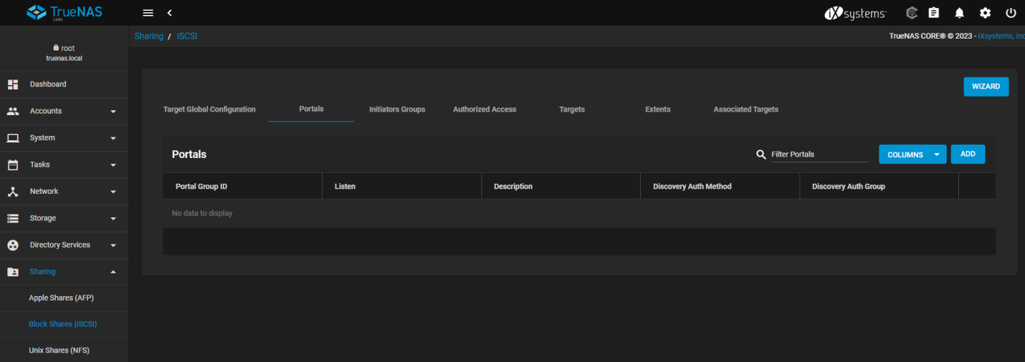

Step34: Then give name and select IP address and submit.

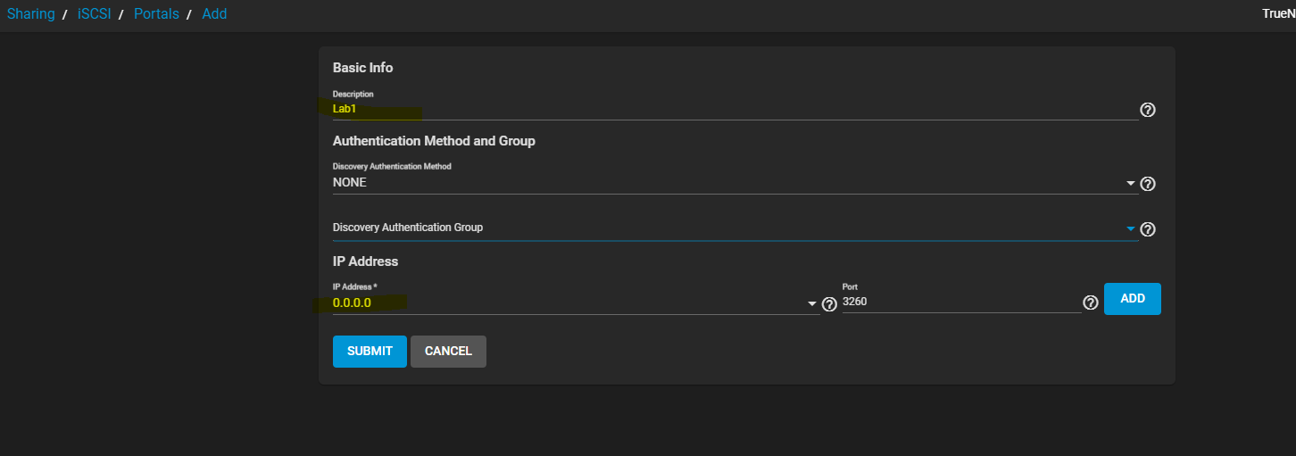

Step35: Go to Initiators -> add -> check on Allow all initiators and save.

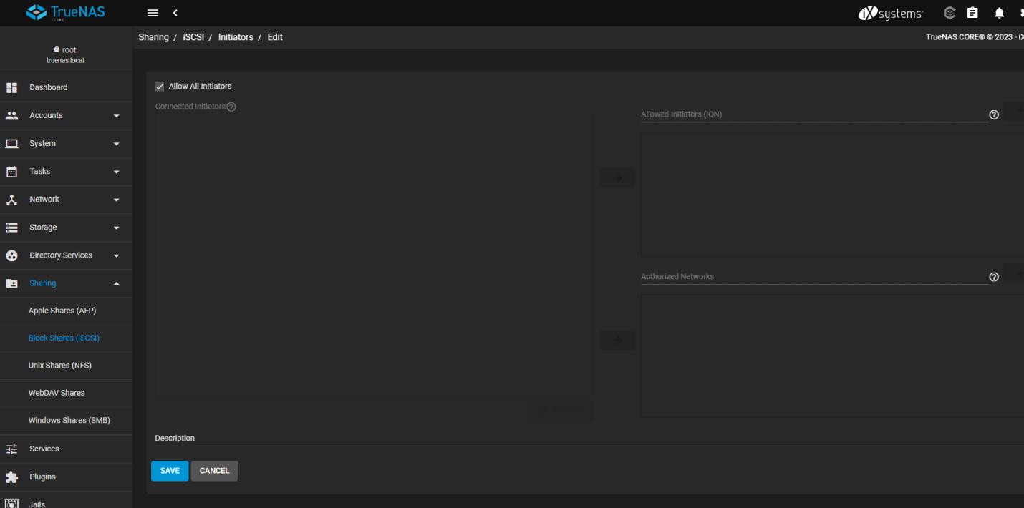

Step36: Then click on target -> add

-write target name

-select Portal group

- Initiators group and click on submit

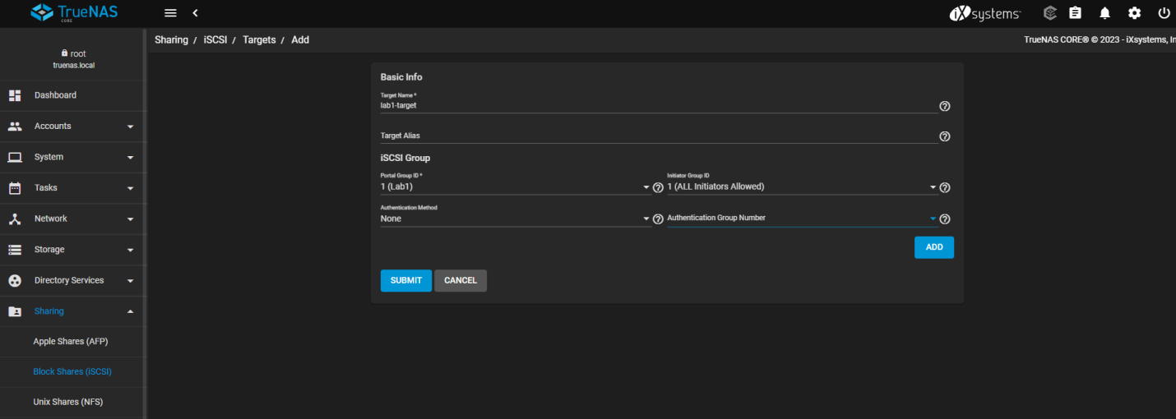

Step37: then Click on Extents -> Add and fill the information

-Give name –labdemo

-Extent Type- File

-Select path and add Win1 folder

-File size 3 GB

-Click on Submit.

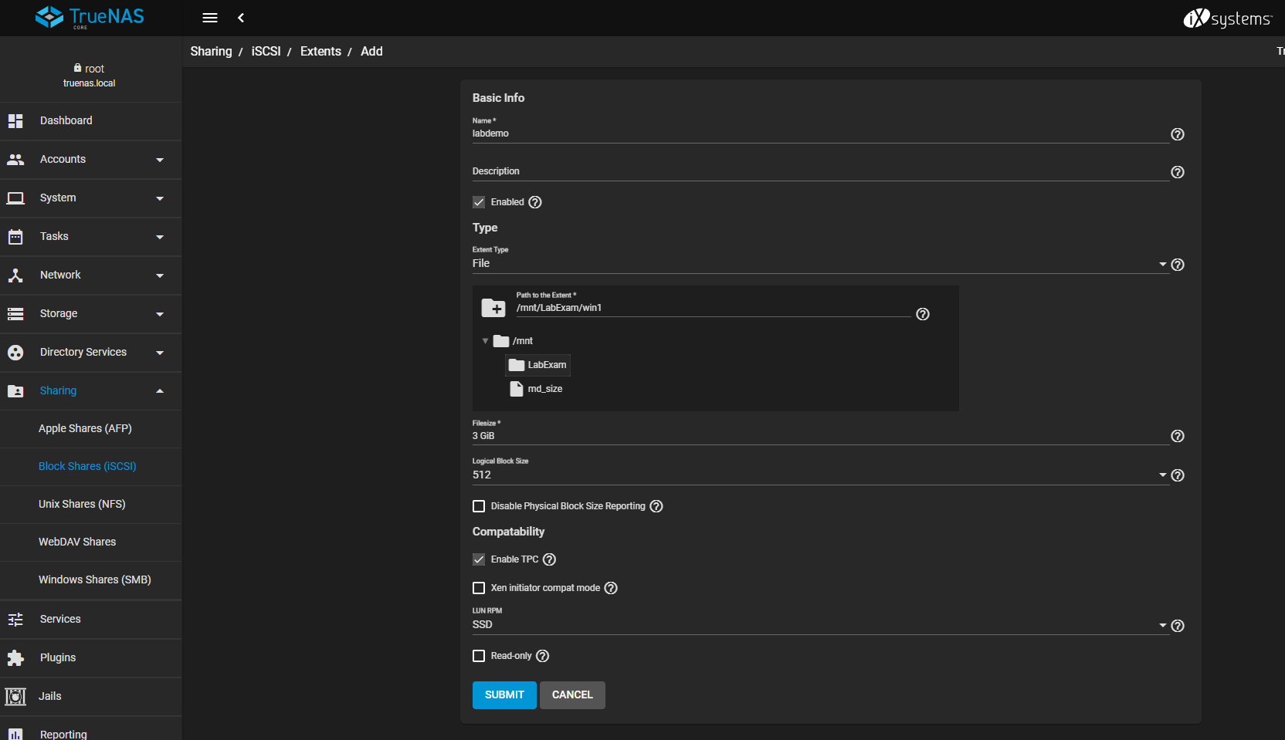

Step38: Click on Associated Targets and click on Add button.

-Select you created target

- Select you created Extent and submit.

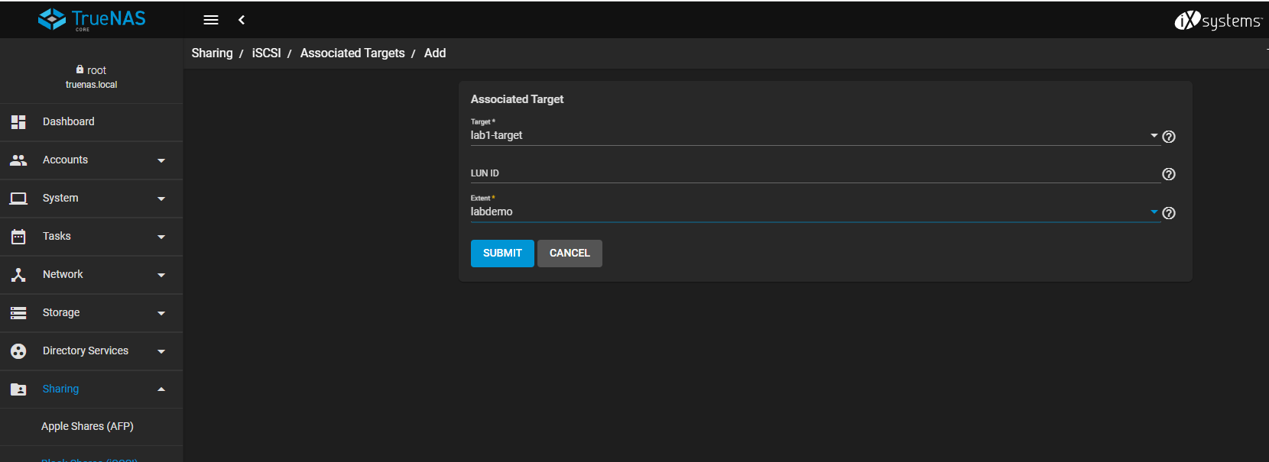

Step39: Then go to services and Restart iSCSI services

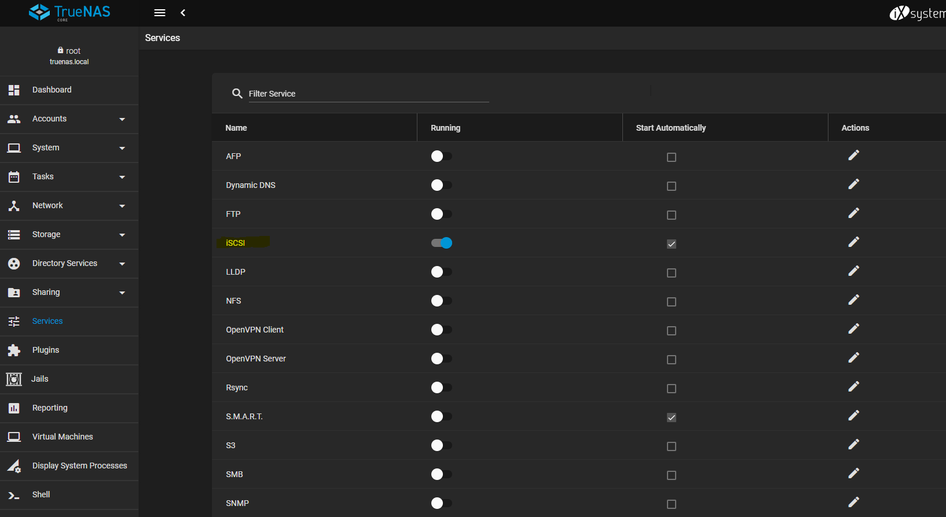

Step40: Then go to Windows search button and search ISCSI initiator, click on that.

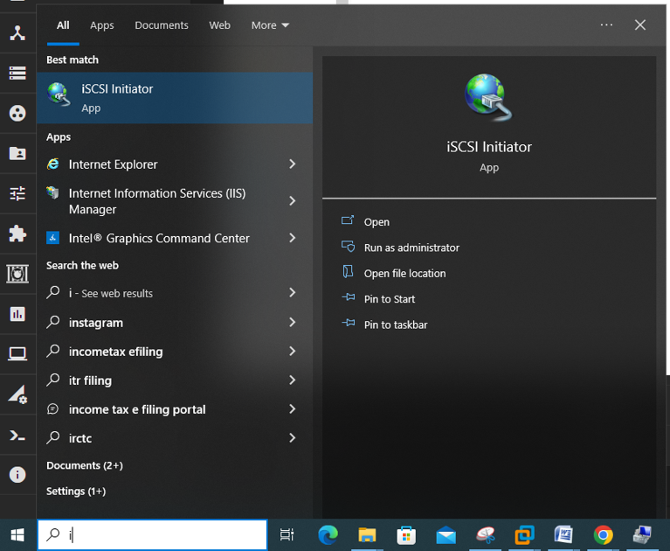

Step41: Then put their True NAS IP address and click on Quick Connect and press done button.

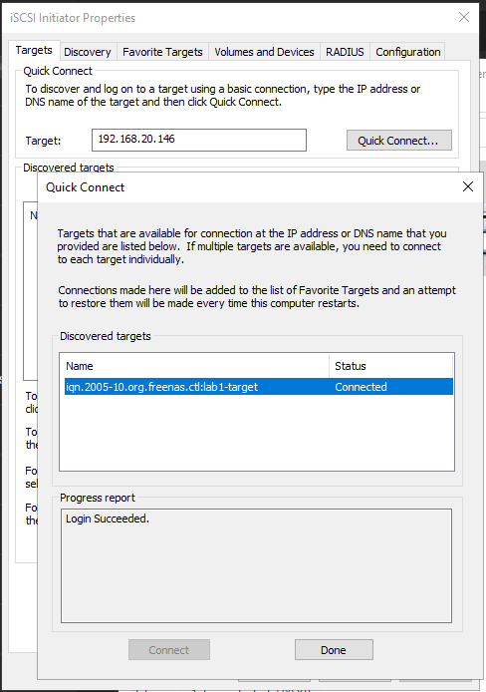

Step42: Then go to the Windows Computer Management right click on Disk2 and initialize disk and Ok.

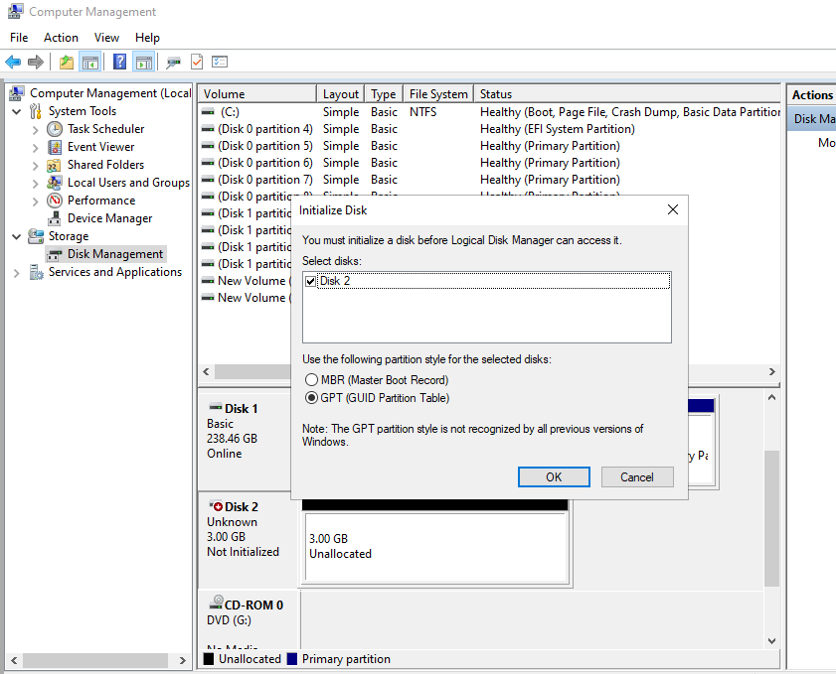

Next

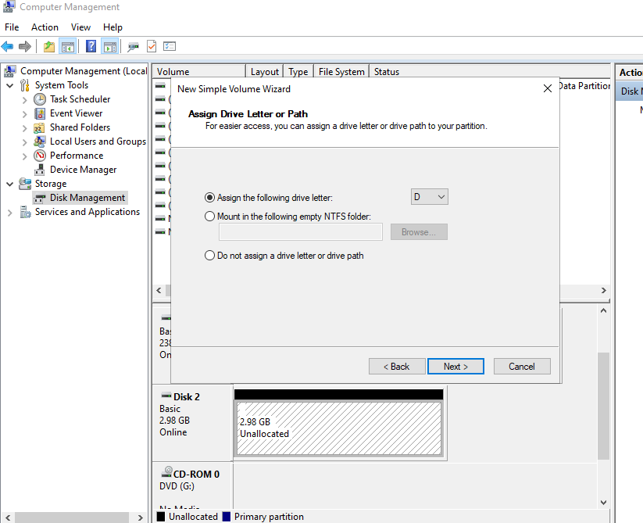

Next and finish.

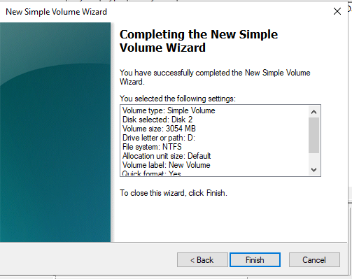

Last Step: Click On this PC and cheeked there drive in created or not.

